# ASSIGNMENT : 2 (LINKED LIST)

Q1.

Code: #include<stdio.h>

#include<stdlib.h>

typedef struct poly {

    int coeff;

    int expo;

    struct poly *next;

} poly;

poly *create() {

    poly *head = NULL, *temp = NULL, *newNode;

    int ch;

    while (1) {

        newNode = (poly *)malloc(sizeof(poly));

        if (newNode == NULL) {

            printf("Memory allocation failed.\n");

            break;

        }

        printf("Enter the coefficient for node: ");

        scanf("%d", &newNode->coeff);

        printf("Enter the exponent for node: ");

        scanf("%d", &newNode->expo);

        newNode->next = NULL;

        if (head == NULL) {

            head = newNode;

        } else {

            temp->next = newNode;

        }

        temp = newNode;

        printf("Do you want to add another term? (1 for yes, 0 for no): ");

        scanf("%d", &ch);s

        if (ch == 0) {

            break;

        }

    }

    return head;

}

poly *addpoly(poly *p1, poly *p2) {

    poly *p3 = NULL, *temp = NULL, *newNode;

    while (p1 != NULL && p2 != NULL) {

        newNode = (poly *)malloc(sizeof(poly));

        if (newNode == NULL) {

            printf("Memory allocation failed.\n");

            break;

        }

        newNode->next = NULL;

        if (p1->expo == p2->expo) {

            newNode->coeff = p1->coeff + p2->coeff;

            newNode->expo = p1->expo;

            p1 = p1->next;

            p2 = p2->next;

        } else if (p1->expo > p2->expo) {

            newNode->coeff = p1->coeff;

            newNode->expo = p1->expo;

            p1 = p1->next;

        } else {

            newNode->coeff = p2->coeff;

            newNode->expo = p2->expo;

            p2 = p2->next;

        }

        if (p3 == NULL) {

            p3 = newNode;

        } else {

            temp->next = newNode;

        }

        temp = newNode;

    }

    while (p1 != NULL) {

        newNode = (poly *)malloc(sizeof(poly));

        if (newNode == NULL) {

            printf("Memory allocation failed.\n");

            break;

        }

        newNode->coeff = p1->coeff;

        newNode->expo = p1->expo;

        newNode->next = NULL;

        if (p3 == NULL) {

            p3 = newNode;

        } else {

            temp->next = newNode;

        }

        temp = newNode;

        p1 = p1->next;

    }

    while (p2 != NULL) {

        newNode = (poly *)malloc(sizeof(poly));

        if (newNode == NULL) {

            printf("Memory allocation failed.\n");

            break;

        }

        newNode->coeff = p2->coeff;

        newNode->expo = p2->expo;

        newNode->next = NULL;

        if (p3 == NULL) {

            p3 = newNode;

        } else {

            temp->next = newNode;

        }

        temp = newNode;

        p2 = p2->next;

    }

    return p3;

}

void display(poly *p) {

    if (p == NULL) {

        printf("Polynomial is empty.\n");

        return;

    }

    while (p != NULL) {

        printf("%dx^%d", p->coeff, p->expo);

        p = p->next;

        if (p != NULL) {

            printf(" + ");

        }

    }

    printf("\n");

}

int main() {

    poly *p1 = NULL, *p2 = NULL, *p3 = NULL;

    printf("Create first polynomial:\n");

    p1 = create();

    printf("Create second polynomial:\n");

    p2 = create();

    printf("Adding polynomials...\n");

    p3 = addpoly(p1, p2);

    printf("Resultant polynomial is:\n");

    display(p3);

    return 0;

}

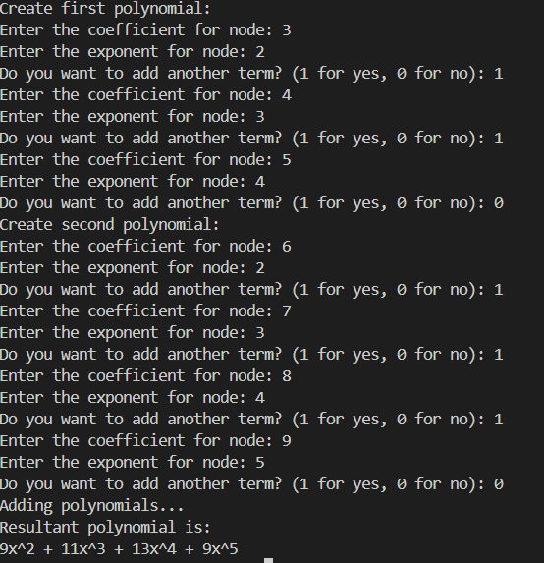

Q2 :

Code :

#include <stdio.h>

#include <stdlib.h>

typedef struct process {

int id;

int burst_time;

struct process* next;

} process;

process* createProcess(int id, int burst_time) {

process* newProcess = (process*)malloc(sizeof(process));

newProcess->id = id;

newProcess->burst_time = burst_time;

newProcess->next = NULL;

return newProcess;

}

void appendProcess(process** head, int id, int burst_time) {

process* newProcess = createProcess(id, burst_time);

if (*head == NULL) {

*head = newProcess;

newProcess->next = *head;

} else {

process* temp = *head;

while (temp->next != *head) {

temp = temp->next;

}

temp->next = newProcess;

newProcess->next = *head;

}

}

void timeSharing(process* head, int time_slot, int total_processes) {

process* current = head;

int completedProcesses = 0;

int total_time = 0;

while (completedProcesses < total_processes) {

if (current->burst_time > 0) {

if (current->burst_time <= time_slot) {

total_time += current->burst_time;

printf("Process %d completed in %d ns\n", current->id, total_time);

current->burst_time = 0;

completedProcesses++;

} else {

current->burst_time -= time_slot;

total_time += time_slot;

}

}

current = current->next;

}

}

int main() {

process* head = NULL;

int N, i, burst_time;

printf("Enter the number of processes: ");

scanf("%d", &N);

for (i = 1; i <= N; i++) {

printf("Enter burst time for Process %d: ", i);

scanf("%d", &burst_time);

appendProcess(&head, i, burst_time);

}

int time_slot;

printf("Enter the time slot for each process (in ns): ");

scanf("%d", &time_slot);

printf("\nTime-sharing simulation:\n");

timeSharing(head, time_slot, N);

return 0;

}

Output :

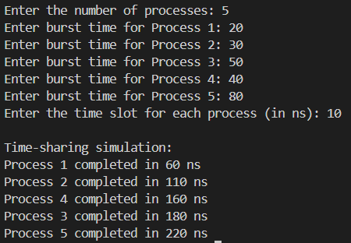

Q3:

Code:

#include <stdio.h>

#include <stdlib.h>

typedef struct node {

int data;

struct node* next;

} node;

node* createNode(int data) {

node* newNode = (node*)malloc(sizeof(node));

newNode->data = data;

newNode->next = NULL;

return newNode;

}

void appendNode(node** head, int data) {

node* newNode = createNode(data);

if (*head == NULL) {

*head = newNode;

} else {

node* temp = *head;

while (temp->next != NULL) {

temp = temp->next;

}

temp->next = newNode;

}

printf("Node with data %d appended.\n", data);

}

void printList(node* head) {

node* temp = head;

if (head == NULL) {

printf("The list is empty.\n");

return;

}

while (temp != NULL) {

printf("%d -> ", temp->data);

temp = temp->next;

}

printf("NULL\n");

}

void reverseList(node** head) {

node* prev = NULL;

node* curr = *head;

node* next = NULL;

while (curr != NULL) {

next = curr->next;

curr->next = prev;

prev = curr;

curr = next;

}

*head = prev;

printf("The list has been reversed.\n");

}

int main() {

node* head = NULL;

int choice, data;

do {

printf("\nMenu:\n");

printf("1. Append Node\n");

printf("2. Print List\n");

printf("3. Reverse List\n");

printf("4. Exit\n");

printf("Enter your choice: ");

scanf("%d", &choice);

switch (choice) {

case 1:

printf("Enter data to append: ");

scanf("%d", &data);

appendNode(&head, data);

break;

case 2:

printf("Current Linked List:\n");

printList(head);

break;

case 3:

reverseList(&head);

break;

case 4:

printf("Exiting program.\n");

break;

default:

printf("Invalid choice! Please try again.\n");

}

} while (choice != 4);

return 0;

}

Output:

